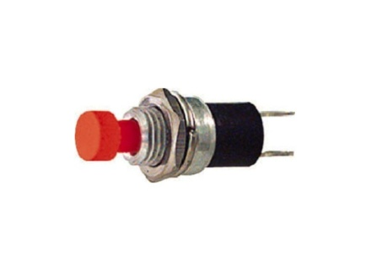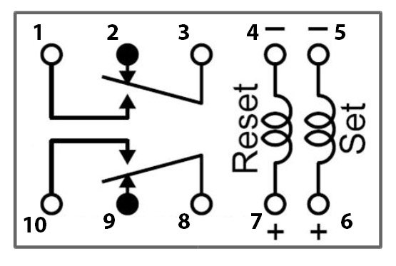

REED

12V cc-

-_-

+

Alim 12Vcc

12V cc+

NA